PS C:\_iGit Clone> docker run --name repo alpine/git clone https://git

hub.com/docker/getting-started.git

Unable to find image 'alpine/git:latest' locally

latest: Pulling from alpine/git

df9b9388f04a: Pull complete

df9126bc4fe8: Pull complete

858ab8ff90cd: Pull complete

Digest: sha256:f87181a6852c6edd1d1494b577813a3f9baec5972ad5f7a9dcbee1c

5d4943403

Status: Downloaded newer image for alpine/git:latest

Cloning into 'getting-started'...

PS C:\_iGit Clone> docker cp repo:/git/getting-started/ .

In Windows >=10, docker desktop creates the VM under

**C:\Users\xxx\AppData\Local\Docker**

**"C:\Users\xxxxx\AppData\Local\Docker\wsl\data "** directory and it is this VM that contains the downloaded docker images.

Read the other document configure sample application (getting-started)-

**Execute getting-started docker sample application.docx**

**Summary commands:**

$ git clone https://github.com/docker/getting-started

$ cd getting-started/

$ docker build -t docker101tutorial .

$ docker run -d -p 50000:80 --name docker-tutorial docker101tutorial

Start you favorite browser and open url

<http://localhost:50000>

<http://localhost:50000/tutorial/>

--

Now we will install **Hashicorp Consul** using docker

Follow the below steps to install consul using the docker image:

* First of all, we need to download the docker image of consul from the docker hub. To pull the consul image, run the docker pull consul command on the terminal.
* Next, we need to run the Consul Agent locally on port **8500** (default port for consul) using docker run -d --name consul -p 8500:8500 consul command.
* Then, start the consul server with docker start consul command. Now, the consul container is up and running on the port 8500. You can check if it is available by navigating to <http://localhost:8500/ui> in your browser.

Or

Simple one line command:

docker run -d -p 8500:8500 --name consul amd64/consul

PS C:\Program Files\Docker\Docker> docker run -d -p 8500:8500 --name consul amd64/consul

docker: Error response from daemon: Conflict. The container name "/consul" is already in use by container "5d6d6f6d9d1c7c5ca130c9bf6bd12842bd53b6ac362954d5b43a97713b86d558". You have to remove (or rename) that container to be able to reuse that name.

See 'docker run --help'.

PS C:\Program Files\Docker\Docker> docker run -d -p 8500:8500 --name consul amd64/consul

Unable to find image 'amd64/consul:latest' locally

latest: Pulling from amd64/consul

6097bfa160c1: Pull complete

8d5eaba874f5: Pull complete

d3c25e702952: Pull complete

ee4e30fdd878: Pull complete

0404bba1e303: Pull complete

0267f66d5e7e: Pull complete

Digest: sha256:e3eca84d5ff52bb0ac7ace85ad62b3b24eaf0f2f5c0a3e93b6560cd2405c2152

Status: Downloaded newer image for amd64/consul:latest

28bbaa5da4d0bfc7f585ec947a79c0afeccc8ee303f5a29dc18f6cba4df72bb7

PS C:\Program Files\Docker\Docker>

**Or**

AzureAD+GangadharParde@Rev-PG02RELN MINGW64 ~

$ docker run -d -p 8599:8500 --name consul amd64/consul

latest: Pulling from amd64/consull:latest' locally

6097bfa160c1: Pulling fs layer

8d5eaba874f5: Pulling fs layer

d3c25e702952: Pulling fs layer

ee4e30fdd878: Pulling fs layer

0404bba1e303: Pulling fs layer

0267f66d5e7e: Pulling fs layer

ee4e30fdd878: Waiting

0404bba1e303: Waiting

8d5eaba874f5: Verifying Checksum

8d5eaba874f5: Download complete

6097bfa160c1: Verifying Checksum

6097bfa160c1: Download complete

6097bfa160c1: Pull complete

8d5eaba874f5: Pull complete

ee4e30fdd878: Verifying Checksum

0404bba1e303: Verifying Checksum

0404bba1e303: Download complete

0267f66d5e7e: Verifying Checksum

0267f66d5e7e: Download complete

d3c25e702952: Verifying Checksum

d3c25e702952: Download complete

d3c25e702952: Pull complete

ee4e30fdd878: Pull complete

0404bba1e303: Pull complete

0267f66d5e7e: Pull complete

Digest: sha256:e3eca84d5ff52bb0ac7ace85ad62b3b24eaf0f2f5c0a3e93b6560cd2405c2152

Status: Downloaded newer image for amd64/consul:latest

5d6d6f6d9d1c7c5ca130c9bf6bd12842bd53b6ac362954d5b43a97713b86d558

Now lets open browser and open consul server

Create sample project in STS with below starters-

**Common Error Docker cannot start on Windows**

**Appwiz.cpl -> Windows features turn on or off**

[**https://docs.docker.com/desktop/windows/troubleshoot/**](https://docs.docker.com/desktop/windows/troubleshoot/)

Windows PowerShell

Copyright (C) Microsoft Corporation. All rights reserved.

Try the new cross-platform PowerShell https://aka.ms/pscore6

PS C:\WINDOWS\system32> Net stop com.docker.service

The Docker Desktop Service service is stopping.

The Docker Desktop Service service was stopped successfully.

PS C:\WINDOWS\system32> Net start com.docker.service

The Docker Desktop Service service is starting.

The Docker Desktop Service service was started successfully.

PS C:\WINDOWS\system32>

The error is related to that part:

In the default daemon configuration on Windows, the docker client must be run elevated to connect

* First, verify that Docker Desktop application is running. If not, launch it: that will run the docker daemon (just wait few minutes).
* Then, if the error still persist, you can try to switch Docker daemon type, as explained below:

***With Powershell***:

1. Open Powershell *as administrator*
2. Launch command: & 'C:\Program Files\Docker\Docker\DockerCli.exe' -SwitchDaemon

***OR, with cmd***:

1. Open cmd *as administrator*
2. Launch command: "C:\Program Files\Docker\Docker\DockerCli.exe" -SwitchDaemon

Starting the docker daemon resolved the issue. Just search for docker pressing windows key and click on "Docker Dekstop". Daemon should be running in a minute. [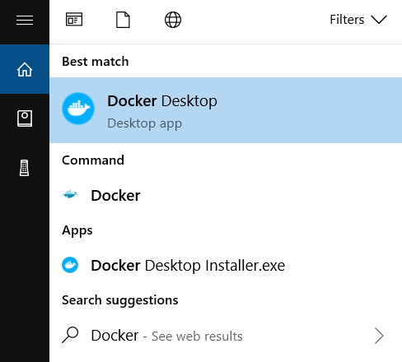](https://i.stack.imgur.com/ivgix.png)

After starting up Docker Desktop, make sure the docker daemon status in the bottom left is green and shows RUNNING when you hover over it.

